SQL ASSIGNMENT – 3

Department Table :

CREATE TABLE Department(

dept_id int IDENTITY (1000,1) PRIMARY KEY NOT NULL,

dept_name NCHAR(50) NOT NULL

)

INSERT INTO Department VALUES ('Finance'),

('Audit'),

('Marketing'),

('Production');

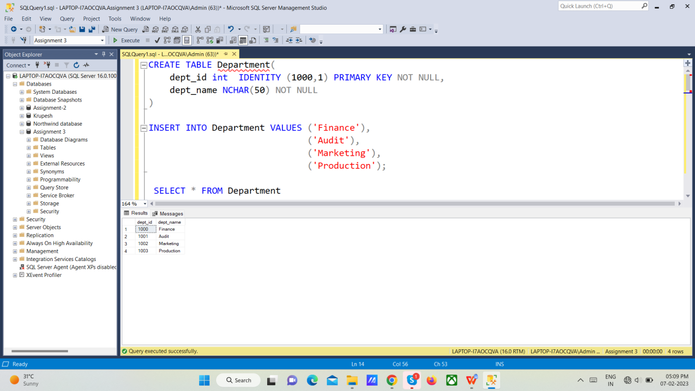

Employee Table :

CREATE TABLE Employee(

emp_id INT IDENTITY (6000, 1) PRIMARY KEY NOT NULL,

dept_id INT NOT NULL,

FOREIGN KEY (dept_id) REFERENCES Department(dept_id),

mnger_id INT NOT NULL,

emp_name NCHAR(50) NOT NULL,

salary INT NOT NULL

)

INSERT INTO Employee VALUES (1001,68319,'Kayling',6000),

(1003,68319,'Blaze',2750),

(1001,68319,'Clare',2550),

(1002,68319,'Jonas',2957),

(1002,65646,'Scarlet',3100),

(1002,65646,'Frank',3100),

(1002,69062,'Sandrine',900),

(1003,66928,'Adelyn',1700),

(1003,66928,'Wade',1350),

(1003,66928,'Madden',1350),

(1003,66928,'Tucker',1600),

(1002,67858,'Adrnes',1200),

(1003,66928,'Julius',1050),

(1001,67832,'Marker',1400)

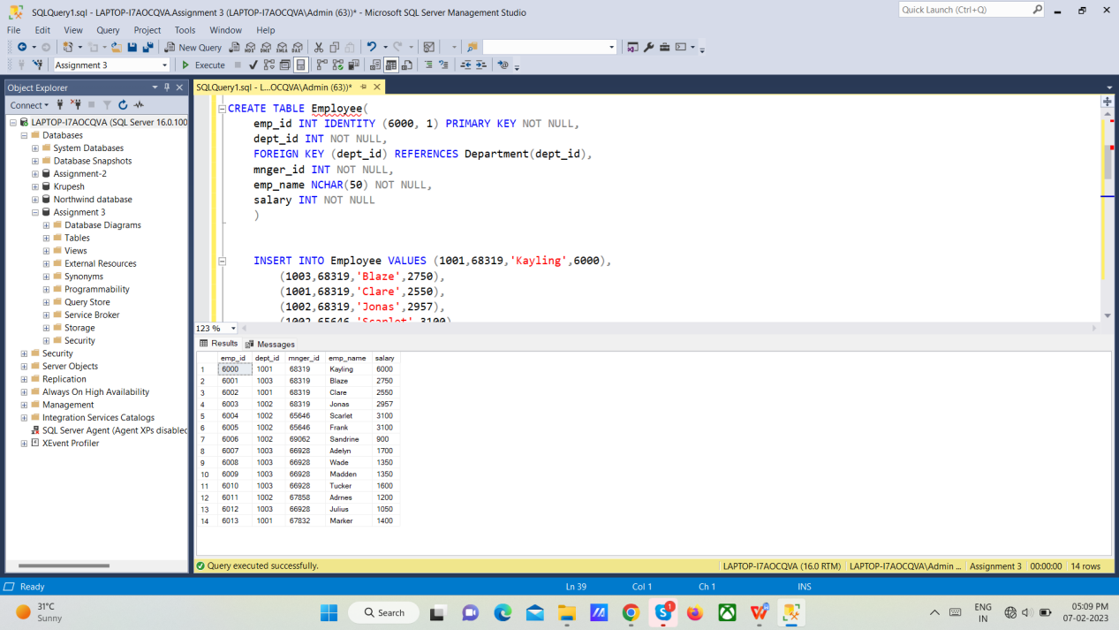

/*QUERY - 1*/

SELECT d.dept_name, e.emp_name, e.salary

FROM Department d

INNER JOIN Employee e

ON d.dept_id = e.dept_id

where e.salary in(SELECT MAX(salary) FROM Employee GROUP BY dept_id)

OUTPUT -

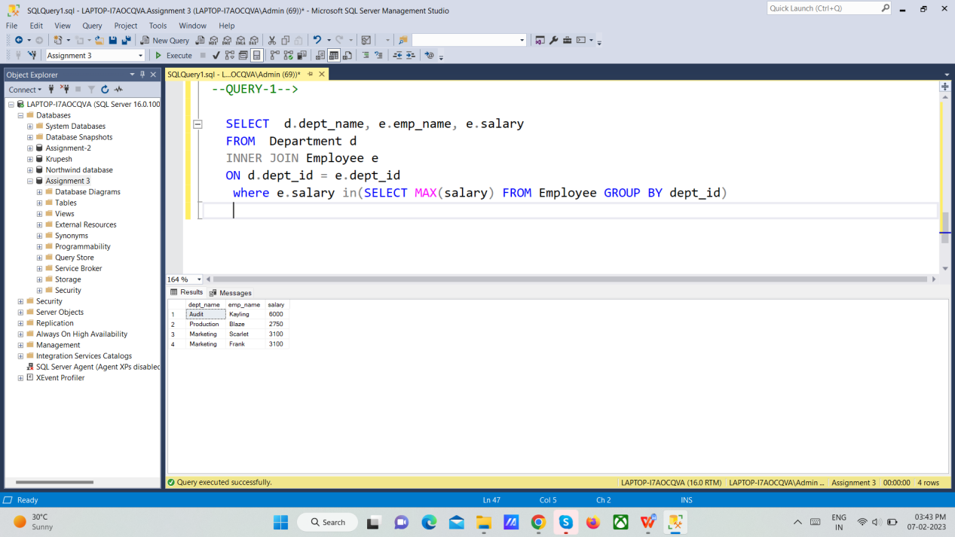

/*QUERY - 2*/

SELECT d.dept_name

FROM Department d

INNER JOIN Employee e

ON d.dept_id = e.dept_id

GROUP BY d.dept_name

HAVING COUNT(*) <= 3;

OUTPUT -

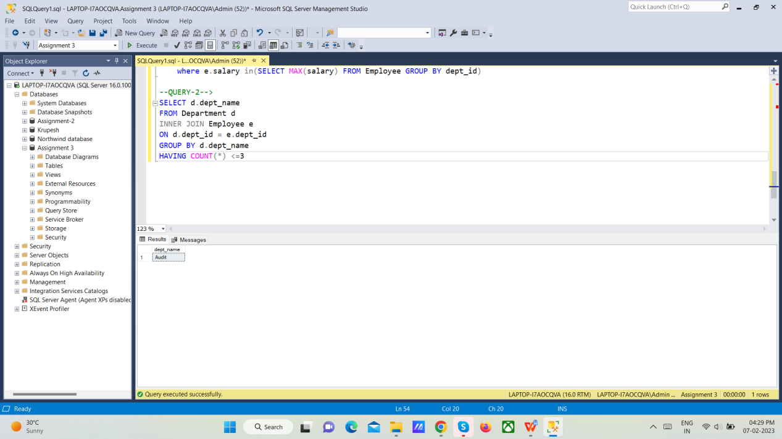

/*QUERY - 3*/

SELECT d.dept_name, COUNT(e.emp_name) AS NoOfEmp

FROM Department d

LEFT JOIN Employee e

ON d.dept_id = e.dept_id

GROUP BY d.dept_name

OUTPUT -

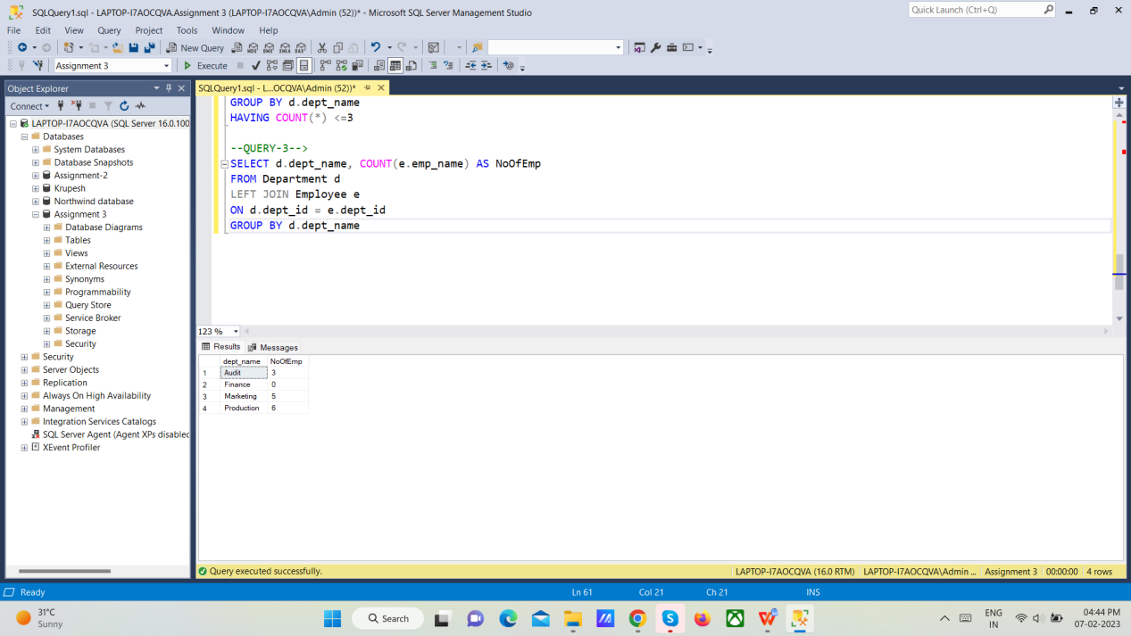

/*QUERY - 4*/

SELECT d.dept_name, SUM(salary) AS TotalSalary

FROM Department d

LEFT JOIN Employee e

ON d.dept_id = e.dept_id

GROUP BY d.dept_name

OUTPUT -

